**CMPS 312 – Mobile Application Development Final Practical Exam – 5 December 2023 (duration 2h)**

|  |  |
| --- | --- |
| Student Name (Student ID) |  |

**Task Overview:**

1. Sync the cmps312-lab repository and copy the Final Exam folder to your GitHub repo, which contains the base project named **NewsHub** and with all necessary dependencies and the testing sheet.
2. Implement a **NewsHub** app that allows users to manage news articles and their categories. Manage the app data in an SQLite database using Room Library.

**Implementation Tasks:**

Sync the Lab repo then copy the final exam folder to your GitHub repo. This folder contains an a base code that has all the needed dependencies and assets required for the exam.

**Implementation Tasks:**

**1. Entity-Relations: [10] :** Create two Entity classes, Category and Article as shown in the figure below, each with proper annotations. Ensure that the IDs are auto-assigned by the database. Add foreign key annotations with cascade delete and update on the appropriate entity.

Figure 1 ER Diagram of NewsHub App

**2. NewsHubDao Interface and NewsHubDatabase [30]** Create the database class and the NewsHubDao Interface with necessary functions and annotations to allow users to:

* Add a new Article
* Get all articles
* Delete an article
* Add a new Category
* Get all categories
* Delete a category and all associated articles
* Update an article's details

1. **NewsHubRepository [10]** Implementthe NewsHubRepository with all necessary methods listed above. Also the inside the repository initialize the database if the database is empty using the provided JSON files.
2. **NewsHubViewModel [20]** Create a NewsHubViewModel to serve as an intermediary between the UI and the repository. The ViewModel should:

* Manage the interaction between the UI and the repository for category and articles data.
* Provide Flows and Observable data to observe changes in the underlying data.
* Handle user inputs and interactions, ensuring proper validation and data integrity.

1. **App UI and Navigation [30]** Implement the UI and navigation as described below

* Initially the app should display all the articles as a List. The list should be populated from the database.

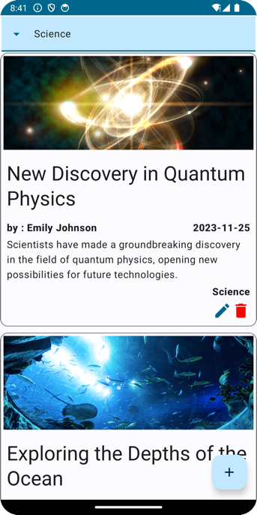

Figure News List Screen

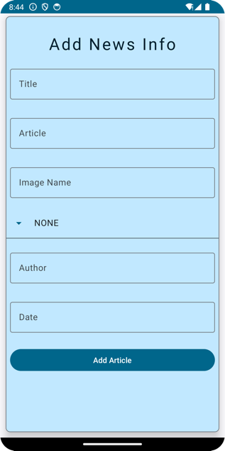

* Clicking on the "Add" button in the article list screen should navigate the user to the article editor screen.
* Clicking on "Edit" in the articles screen should load the article editor screen, and should allow the user to update the current articles properties.
* Add a delete button to each article to allow the user to delete an article in the databse.
* Implement filter news articles by category: All, Politics, Technology, or Business. The filtering should be done in the database.

Figure 3 : Add, Edit New Article

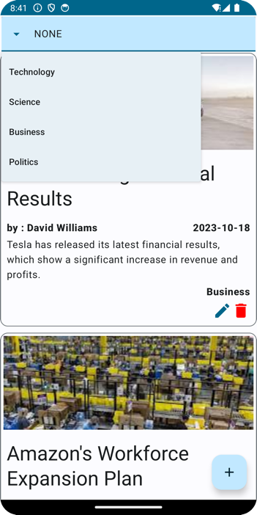

Figure : Filter News

**Submission Requirements:**

* Provide screenshots in Testing-GradingSheet.docx.
* Grading for functionality includes complete and working (70%), complete but not working (lose 30%), and not done (0%).
* The remaining grade is assigned based on the quality of the implementation.